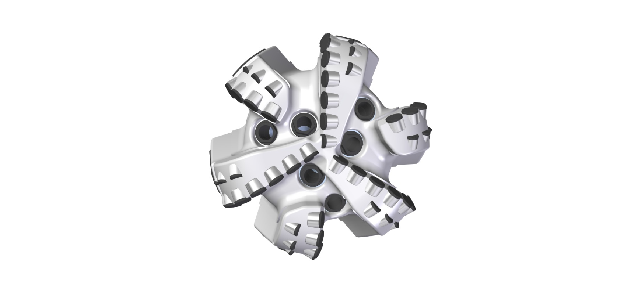 |  | 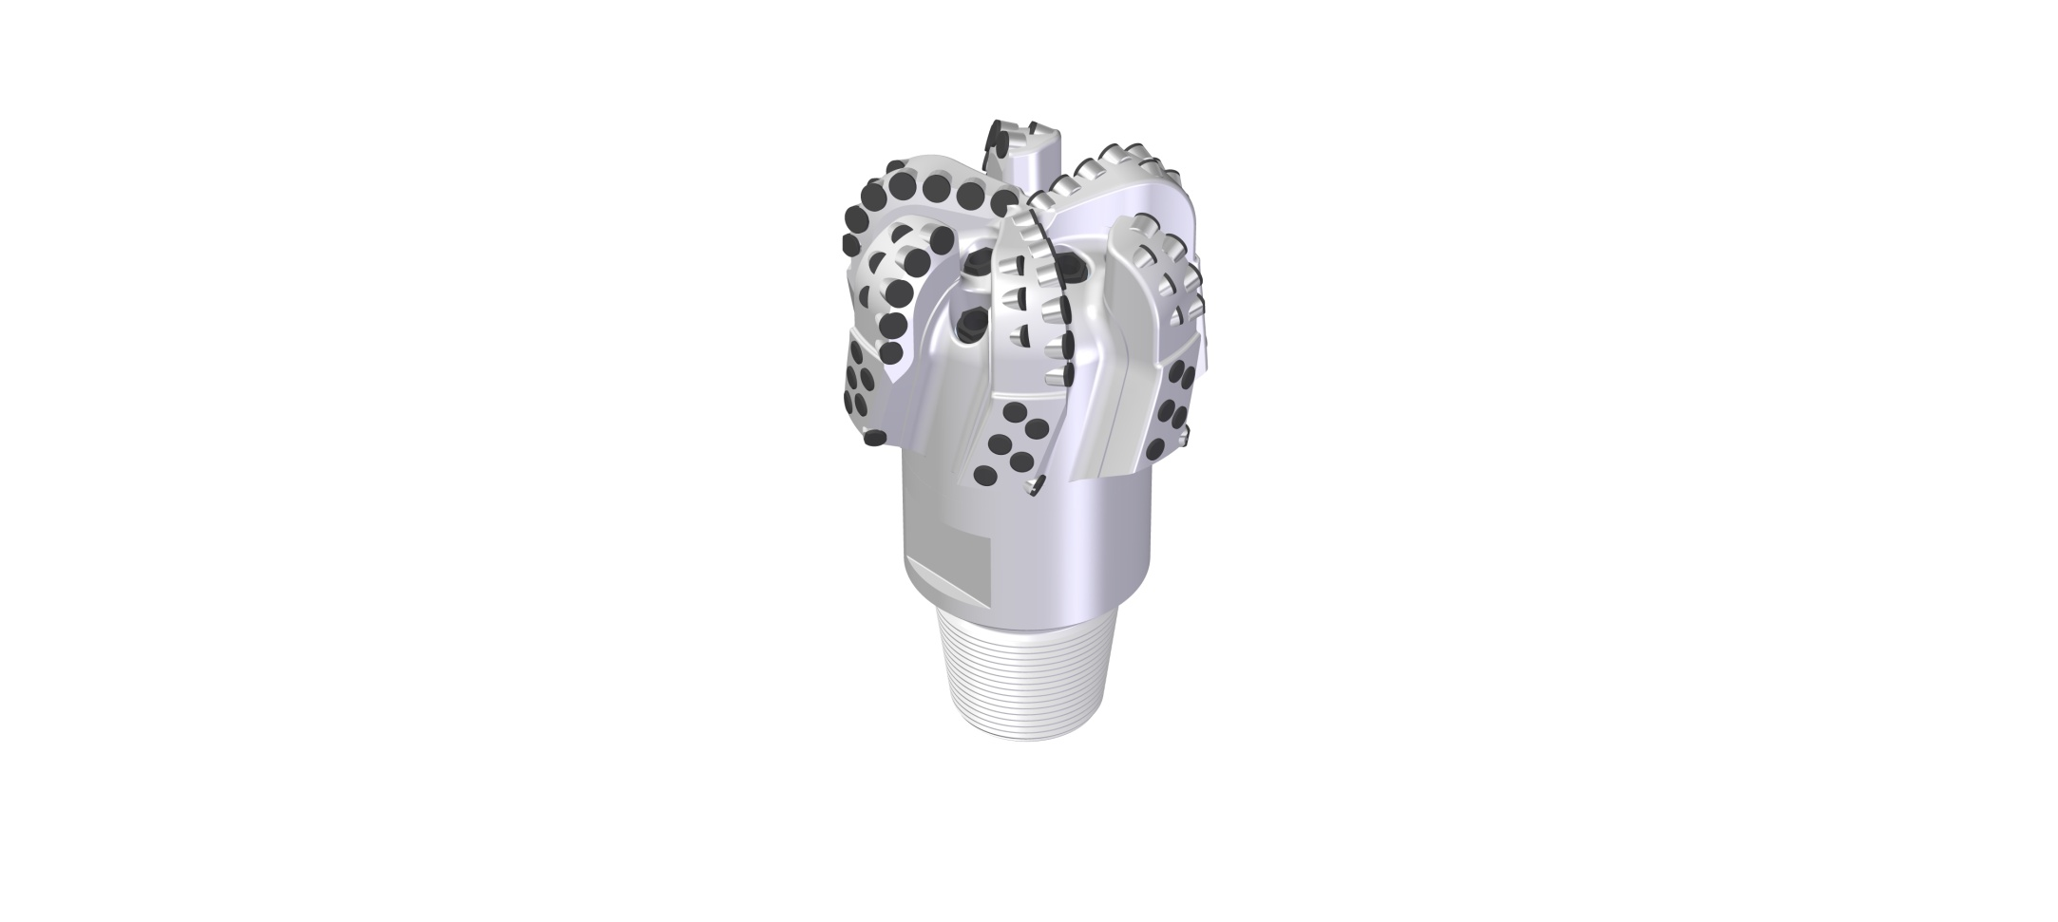

Drill Bit Specifications:
Cutter Size (Primary, Sec, Back Ream) | 5/8”, 1/2”, 1/2”
Cutter Count (Total, Gage, Back Ream) | 60, 10, 6
Blade Count | 6
Gage Length (Inches) | 2.50
Nozzle Count | 6
Nozzle Size | 60
JSA (Sq. Inches) | 15.17
Max. TFA (Sq. Inches) | 2.23
Operating Parameters:
Hydraulic Flow Rate (Max gpm) | 690
Max. Weight on Bit (1,000 Lbs.) | 32
Make-up Torque (ft/lbs) | 16,488
Nominal Dimensions:
Overall Length (Inches) | 14.31
Make Up Length (Inches) | 10.25
Bit Breaker | SKB-21010
Connection | Ø4-1/2" API Reg.
Approx. Weight (Lbs.) | 95

Standard Features:

- Large open face volume assists cuttings removal
- Six nozzles optimize blade cleaning and cuttings removal
- PDC wear inserts on each blade ensure the longevity of the gage.
- Premium grade cutters maximize ROP and Life

616-YR(BR) Nomenclature Explained:

- 6 = Number of Blades
- 16 = Primary Cutter Size (16mm)
- YR = Backup Cutters
- 6 = *Number of Nozzles
- BR = Back Reaming Cutters
*Interchangeable nozzles.

